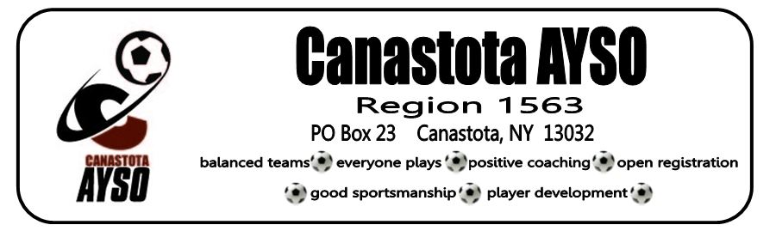

Sign up starting June 26th for the following divisions: Please note age determination
is by year of birth for each division and children in playground need to be 3 by start
of the season and 4 by start of season for 6U.

DIVISION | AGE/ YEAR OF BIRTH
PLAYGROUND (PENDING COACH) | 3 YEAR OLDS (2019)
6U | 4-5 YEAR OLDS (2018 & 2017)
8U | 6-7 YEAR OLDS (2016 & 2015)
10U | 8-9 YEAR OLDS (2014 & 2013)
12U | 10-11 YEAR OLDS (2012 & 2011)
PAYMENT DETAILS |  | PRICE PER PLAYER
Fall Registration Fee per Player: Registration includes: Jersey, shorts and socks |  | $62.75  (Breakdown: $40.00 Regional Registration, $20.00 National Registration, $2.75 Registration Service Fee)
Spring Early Bird Registration along with Fall Registration Fee per Player: Registration includes: Jersey, shorts and socks |  | $82.75  Best Deal!
Playground Registration Fee per Player:  Registration includes: t-shirt  PLEASE SIGN UP ONLINE TO BE PLACED ON WAIT LIST & WE WILL NOTIFY YOU TO COMPLETE PAYMENT, UPON CONFIRMATION OF COACH. |  | $42.75  (Breakdown: $20.00 Regional Registration, $20.00 National Registration, $2.75 Registration Service Fee)
Our region cannot run without lots of volunteers! How can you help?
Coach & Assistant Coach contact: coach administrators: Nichole Boston: nboston271989@gmail.com or Nicole Chase: nchase717@gmail.com
Referee
Board of Directors
Special Events
Please contact our board members for more details on our volunteer opportunities and sign up online!

How to Register: Go onto www.canastotaayso.org to register online. Please note we are only accepting credit/debit card payment online only!
Please note you must sign up for the Fall to take advantage of the Early Bird Spring Registration Deal. If undecided about the Spring we will be having a separate registration in early 2023.

Scholarships available. Visit our website/contact our registrar for details.
Please have your child wear cleats, shin guards and socks and bring a soccer ball to practice.
Any questions regarding registration please reach out to our Registrar: Jen Kitchen via email at jbourg@twcny.rr.com or via phone or text at: 315-558-2974.
Please register online by August 8th, 2022 to avoid being put on a waiting list.

